**Bytewise fellowship: Data Engineering**

**Task 7:**

**DML COMMANDS**

**Insert :**

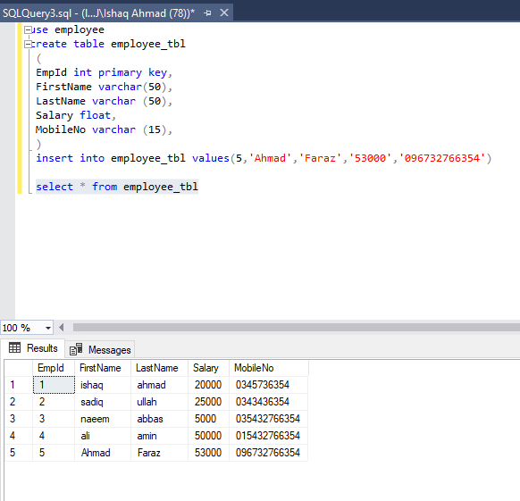

**Update: row 4 has been updated**

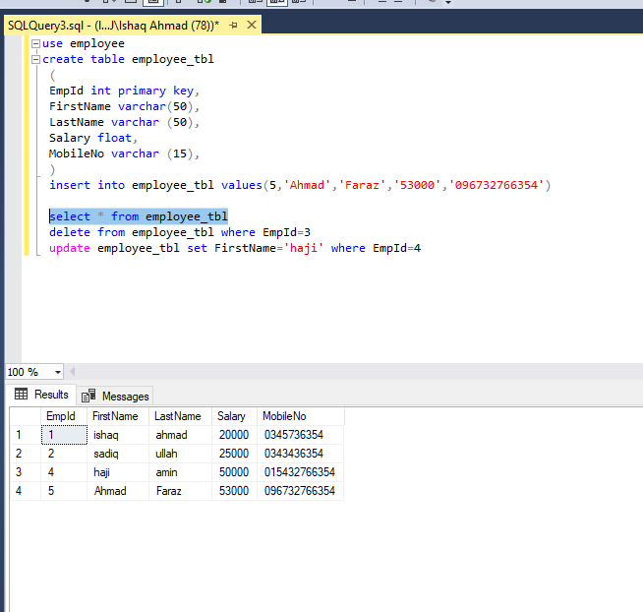

**Delete: one row deleted**

